

ITC-511 Application, Maintenance and Testing

Documentation of End Users Help (2019)

Dikshant Shrestha & Bhim | ITC-511 Group-5 | 03/04/2019

Submitted to David Cartman

Help Manual

1. How to setup easy appointments?
2. How to login to back-end section?
3. How to recover administrator profile password?
4. How to add new appointment?
5. How to

Easy appointments Setup:

* Open IP server link from aws instance and click on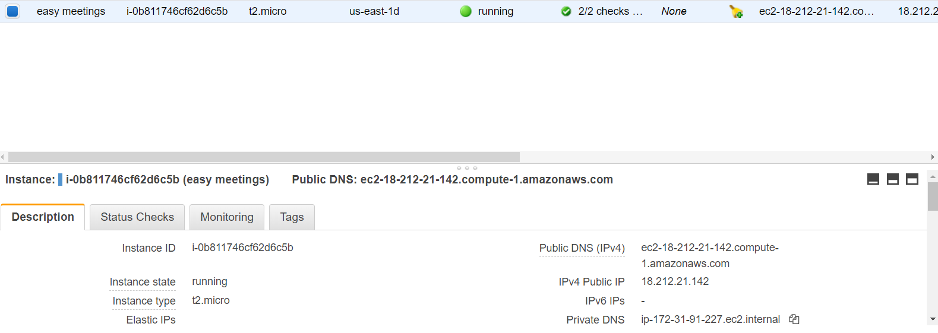
* <http://3.94.201.11/index.php/backend>
* Then you gain access towards Easy appointments.
* Fill the details

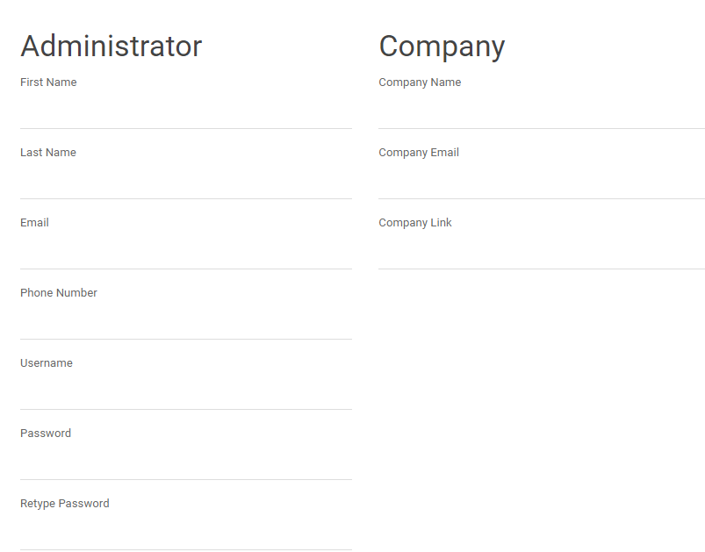

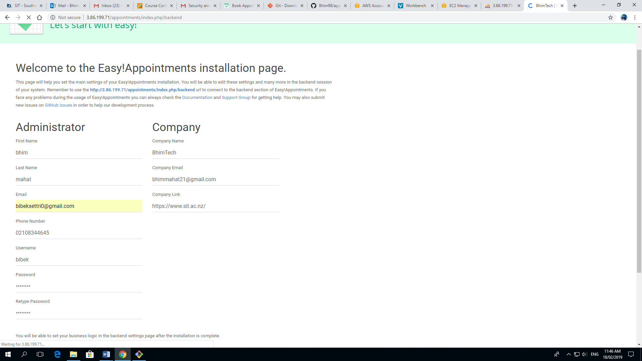

* After filling your details click on install easy appointments.

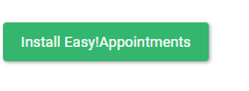

Booking page Steps:

* On this page, simply click on go to Booking page



* Select your provider and service and press next button.

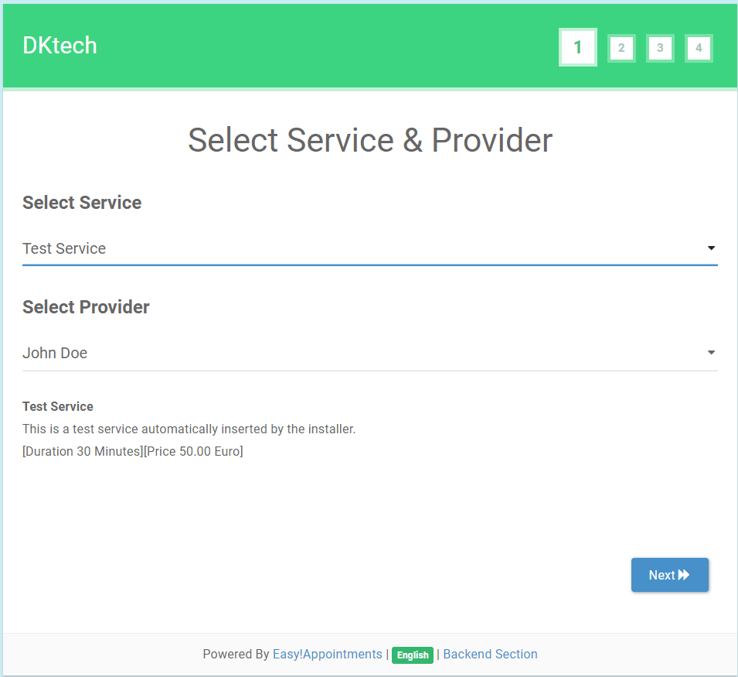

* And then choose date, calendar and time to get appointments and click next to other page.

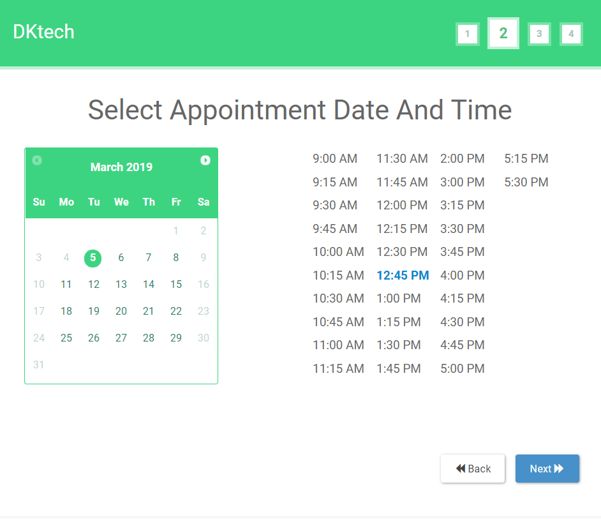

* In fill your information first name, last name, email and phone number are mandatory and click next

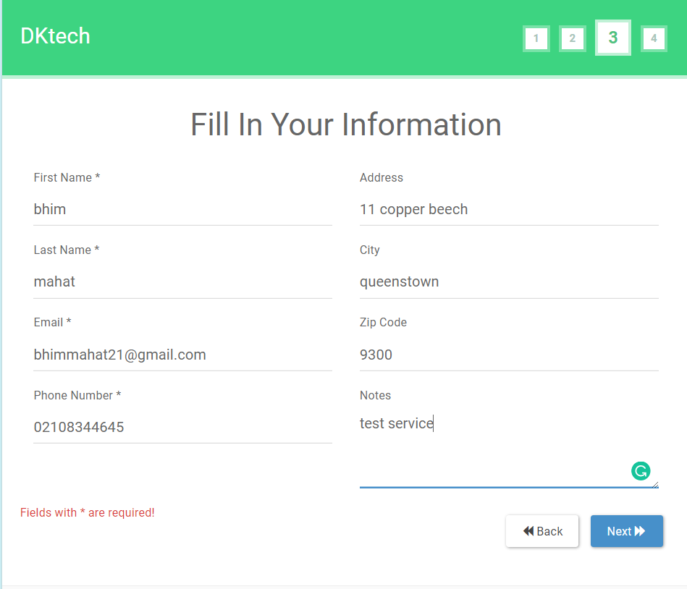

* At last page, check your details and check your time,date price and press confirm
* Now your appointment date is fixed

